 | TEXTILE ORDER AND SUPPLY TRACKING SYSTEM | 

Knowledge demonstration REPORT

Submitted by

AKASH G
(730923201007)

in partial fulfillment of the requirement
for the award of the degree
of
B.TECH
in
ARTIFICIAL INTELLIGENCE AND DATA SCIENCE

EXCEL ENGINEERING COLLEGE
(An Autonomous Institution, affiliated to Anna University Chennai and Approved by AICTE, New Delhi)
KOMARAPALAYAM - 637303
MAY - 2026
EXCEL ENGINEERING COLLEGE (AUTONOMOUS)
KOMARAPALAYAM - 637303
BONAFIDE CERTIFICATE
Certified that this Knowledge Demonstration Project report titled “TEXTILE ORDER AND SUPPLY TRACKING SYSTEM” is the bonafide work of AKASH G ( 730923201007 ) who carried out this work under my supervision.
SIGNATURE | SIGNATURE
Dr.P.JAYAPRABHA M.E Ph.D. | Dr.C.EBENEXCELINE,M.Tech.,Ph.d
HEAD OF THE DEPARTMENT | SUPERVISOR
Department of AI&DS | Department of AI&DS
Excel Engineering College | Excel Engineering College
Komarapalayam - 637303 | Komarapalayam - 637303

Submitted for the viva-voce examination held on ……………

Internal Examiner External Examiner
ABSTRACT

The Textile Order and Supply Tracking System is a comprehensive digital solution developed to enhance the efficiency and transparency of textile industry operations. Traditional textile management processes often rely on manual record-keeping and fragmented communication, leading to delays, errors, and lack of real-time visibility. This system addresses these challenges by providing an integrated platform for managing orders, tracking supply chains, and monitoring inventory in a streamlined manner.
The proposed system enables manufacturers, suppliers, and distributors to efficiently handle the complete lifecycle of textile orders, from order placement and production scheduling to dispatch and delivery. It offers key functionalities such as real-time order tracking, automated inventory updates, supplier coordination, and status notifications. These features help reduce operational delays, minimize human errors, and improve coordination among stakeholders.
In addition, the system incorporates a centralized database that ensures secure storage and easy retrieval of information. Analytical tools and reporting features provide valuable insights into production trends, supply chain performance, and resource utilization, enabling better decision-making. The user-friendly interface ensures accessibility and ease of use for individuals with varying levels of technical expertise.
By leveraging modern web technologies, the Textile Order and Supply Tracking System significantly improves operational efficiency, enhances supply chain visibility, and supports timely delivery of products. Ultimately, the system contributes to increased productivity, reduced costs, and improved customer satisfaction, making it a valuable solution for modern textile enterprises.
Furthermore, the system is designed to be scalable and adaptable, allowing integration with future technologies such as AI-based demand prediction and automated logistics management. This ensures long-term usability and continuous improvement in textile supply chain operations.
Additionally, the system enhances traceability by maintaining detailed records of each transaction and movement within the supply chain. This improves accountability and enables quick identification and resolution of issues, ensuring consistent quality and reliability in operations.
TABLE OF CONTENTS

CHAPTER | TITLE | PAGE
1 | INTRODUCTION | 4
 | 1.1 Project Motivation
 | 1.2 Problem Statement
 | 1.3 Objectives and Scope
2 | LITERATURE REVIEW | 5
 | 2.1 Summary
 | 2.2 Research Gap
3 | PROBLEM FORMULATION | 6
 | 3.1 Challenges in this Systems
 | 3.2 Existing Solutions and Limitations
 | 3.3 Identified Gaps
4 | SYSTEM DESIGN AND METHODOLOGY | 7-8
 | 4.1 System Architecture Overview
 | 4.2 Architecture Diagram
 | 4.3 Step-by-Step Workflow Design
 | 4.4 Technology Stack
5 | IMPLEMENTATION DETAILS | 9
 | 5.1 Backend Implementation
 | 5.2 Frontend Implementation
 | 5.3 Database and API Design
6 | RESULTS AND DISCUSSION | 10
 | 6.1 Functional Outputs
 | 6.2 Discussion and Analysis
7 | ADVANTAGES AND APPLICATIONS | 11
 | 7.1 Platform Advantages
 | 7.2 Real-World Application Domains
8 | LIMITATIONS AND FUTURE SCOPE | 12
 | 8.1 Current Limitations
 | 8.2 Future Enhancement Roadmap
9 | CONCLUSION | 13
10 | REFERENCES | 14
CHAPTER 1
INTRODUCTION

1.1 Project Motivation
The motivation behind developing the Textile Order and Supply Tracking System arises from the increasing complexity and inefficiencies observed in traditional textile management processes. In many small and medium-scale textile industries, order handling, inventory tracking, and supply coordination are still performed manually or through disconnected systems. This often leads to delays, miscommunication, data inconsistencies, and lack of real-time visibility, ultimately affecting productivity and customer satisfaction. With the rapid growth of the textile market and rising customer expectations for timely delivery and quality assurance, there is a strong need for a unified digital solution that can streamline operations and improve coordination among stakeholders
1.2 Problem Statement
The textile industry faces significant challenges in managing orders and supply chain operations due to reliance on traditional, manual, and fragmented systems. Many textile businesses lack a centralized platform to efficiently handle order processing, inventory management, and supply tracking. As a result, they encounter frequent issues such as delays in order fulfillment, inaccurate inventory records, poor coordination among stakeholders, and limited visibility into the status of orders and supplies. In existing systems, communication gaps between manufacturers, suppliers, and distributors often lead to misunderstandings, duplication of work, and inefficient resource utilization.
1.3 Objectives and Scope
The Textile Order and Supply Tracking System provides a centralized platform to manage textile orders, inventory, and supply chain activities efficiently. It enables real-time tracking of orders from production to delivery while improving communication between manufacturers, suppliers, and distributors. The system aims to reduce manual work, minimize errors, and ensure accurate data management. Additionally, it enhances transparency, supports better decision-making, and is designed to be scalable for future improvements, ultimately improving overall efficiency and customer satisfaction. enhance coordination and efficiency across all stages of the textile workflow.

CHAPTER 2
LITERATURE REVIEW

2.1 Summary
The Textile Order and Supply Tracking System is a web-based solution developed to improve the efficiency and transparency of textile industry operations. The system focuses on simplifying order management, inventory tracking, and supply chain coordination by providing a centralized platform for all stakeholders. It addresses common challenges such as manual data handling, lack of real-time visibility, and poor communication between manufacturers, suppliers, and distributors.
Through features like real-time order tracking, automated inventory updates, and centralized data management, the system ensures accurate and timely information flow across all stages of the workflow. This reduces delays, minimizes human errors, and enhances overall productivity. The user-friendly interface allows easy access and operation, making it suitable for users with different levels of technical expertise.
2.2 Research Gap
Despite the growing adoption of digital solutions in supply chain management, many existing systems in the textile industry remain fragmented, lack integration, and do not fully address the specific needs of textile order processing and supply tracking. Current solutions often focus either on inventory management or order processing independently, without providing a unified platform that connects all stakeholders such as manufacturers, suppliers, and distributors. This lack of integration leads to inefficiencies, communication gaps, and limited visibility across the supply chain.
Furthermore, many available systems do not offer real-time tracking and updates, which are critical for ensuring timely delivery and effective decision-making. The absence of centralized data management also results in inconsistencies, duplication of data, and increased chances of human error. Additionally, small and medium-scale textile businesses often lack access to affordable and user-friendly digital tools tailored to their operational requirements. Another significant gap is the limited use of scalable and adaptable technologies that can support future enhancements such as predictive analytics and automated supply chain optimization

CHAPTER 3
PROBLEM FORMULATION

3.1 Challenges in this System
• Managing real-time synchronization of order, inventory, and supply data across multiple users
• Ensuring accurate and consistent data handling to avoid duplication and errors
• Integrating different modules such as order management, inventory, and tracking into a unified system
• Handling scalability as the number of users, orders, and products increases
• Maintaining secure data storage and protecting sensitive business information
• Designing a user-friendly interface for users with varying technical knowledge
• Managing API integrations (e.g., payment gateways or external services) effectively
• Ensuring smooth communication between frontend and backend systems
3.2 Existing Solutions and Limitations
In the textile industry, existing solutions for order and supply management primarily include manual record-keeping, spreadsheet-based systems, and basic enterprise resource planning (ERP) tools. Many small and medium-scale businesses still rely on traditional methods such as paper records or standalone software to manage orders, inventory, and supplier details. While these approaches may handle basic operations, they lack integration and real-time capabilities. Some advanced ERP systems provide broader functionalities, but they are often complex, expensive, and not tailored specifically to the needs of textile businesses.
3.3 Identified Gaps
The analysis of existing systems in the textile industry reveals several critical gaps that hinder efficient order and supply management. One of the primary gaps is the lack of a centralized platform that integrates order processing, inventory management, and supply tracking into a single system. Most current solutions operate in isolation, leading to fragmented data and poor coordination among stakeholders. Another significant gap is the absence of real-time tracking and updates, which limits visibility into order status and supply chain activities. This makes it difficult for businesses to make timely decisions and respond to changes effectively.
CHAPTER 4
SYSTEM DESIGN AND METHODOLOGY

4.1 System Architecture Overview
The Textile Order and Supply Tracking System is designed as a simple and efficient web-based system that allows manufacturers, suppliers, and distributors to manage orders and track supply activities. Users interact with the system through a user-friendly interface to place orders, update inventory, and check order status.
The system includes main modules such as Order Management, Inventory Management, Real-Time Tracking, and Reporting. All these modules are connected to a central database where all data is stored and managed. This helps in maintaining accurate and consistent information.
The backend processes handle the system logic and ensure smooth functioning. The system also supports external integrations like payment services and includes basic security features such as login authentication and data protection. Additionally, it provides notifications, data backup, and simple reports for better understanding of operations.
4.2 Architecture Diagram
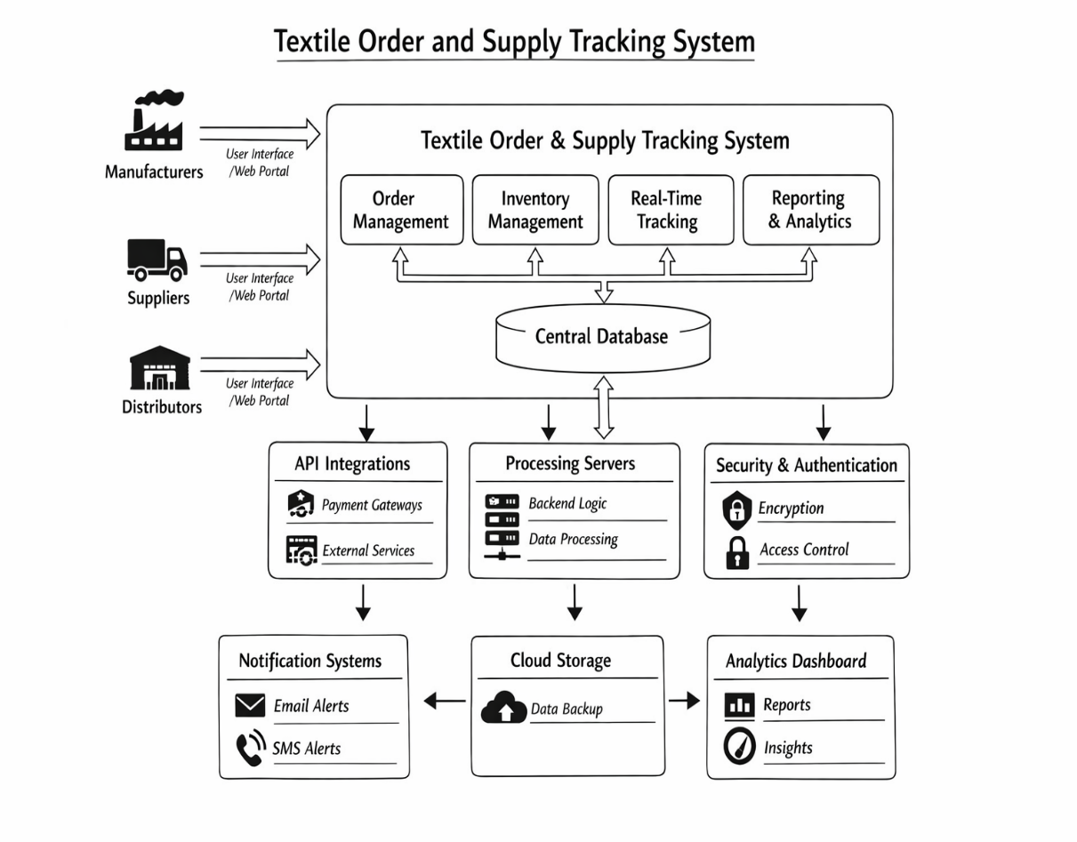
4.3 Step-by-Step Workflow Design
- User logs into the system.
- User places an order.
- System saves the order in the database.
- Inventory is checked and updated.
- Supplier provides required materials.
- Order is processed and prepared.
- Order status is tracked in real time.
- Notifications are sent to the user.
- Product is delivered by the distributor.
- Final status is updated and stored.
4.4 Technology Stack
• Frontend (HTML, CSS, JavaScript): Used to design and develop the user interface, enabling users to interact with the system through web pages with responsive layouts and dynamic functionalities.
• Styling (CSS): Provides custom design and responsive layout to ensure the application looks consistent and works smoothly across different devices.
• Backend (Supabase): Acts as a cloud-based backend service that handles database operations, authentication, and API management without requiring a separate server.
• Database (PostgreSQL - Supabase): Stores all system data such as user details, orders, products, and inventory in a structured and secure format.
• Authentication (Supabase Auth): Manages user login and registration securely, ensuring authorized access to the system.
• API Integration (REST APIs): Enables communication between frontend and backend, and integrates external services like payment systems.
• Payment Gateway (Razorpay): Facilitates secure online payments through multiple methods such as UPI, cards, and net banking.
• Development Tools (Visual Studio Code): Provides a powerful coding environment with extensions and debugging tools to enhance productivity.
CHAPTER 5
IMPLEMENTATION DETAILS

5.1 Backend Implementation
The backend of the Textile Order and Supply Tracking System is implemented using Supabase, a cloud-based backend-as-a-service platform that simplifies server-side development. It provides essential functionalities such as database management, authentication, and API services, eliminating the need for a traditional backend server.
The system uses a PostgreSQL database provided by Supabase to store and manage all application data, including user details, product information, orders, and inventory records. The database is structured with appropriate tables and relationships to ensure data consistency, integrity, and efficient retrieval. CRUD (Create, Read, Update, Delete) operations are performed through Supabase APIs, enabling seamless interaction between the frontend and backend.

5.2 Frontend Implementation
The frontend of the Textile Order and Supply Tracking System is developed using HTML, CSS, and JavaScript to create an interactive and responsive user interface. HTML is used to structure pages such as order placement forms, supplier management, and tracking dashboards, while CSS enhances the visual appearance with responsive layouts, colors, and styling for better user experience. JavaScript adds dynamic functionality such as form validation, real-time updates, filtering orders, and handling user interactions without reloading the page.

5.3 Database and API Design
The system uses MongoDB as the database along with RESTful APIs to manage and exchange data efficiently between the frontend and backend. MongoDB stores data in collections such as users, orders, suppliers, and products using a flexible JSON-based structure, allowing easy scalability and modification. The API layer handles operations like creating new orders, retrieving order details, updating supply status, and deleting records using HTTP methods such as POST, GET, PUT, and DELETE.

CHAPTER 6
RESULTS AND DISCUSSION

6.1 Functional Outputs
The Textile Order and Supply Tracking System produces several functional outputs that support efficient management of textile operations. One of the primary outputs is the real-time display of order status, allowing users to track orders from placement to delivery. This includes updates such as order confirmation, processing, shipment, and final delivery status.
The system also generates inventory status outputs, showing current stock levels, product availability, and updates after each transaction. This helps users maintain accurate inventory records and avoid issues like stock shortages or overstocking. Additionally, the system provides notifications and alerts through the interface, informing users about order updates, low stock levels, and important activities.
Another important output is the generation of reports and analytics, which include summaries of orders, sales performance, and supply chain activities. These reports help users analyze trends and make informed decisions. The system also produces transaction records and history logs, ensuring transparency and easy tracking of all activities within the system.
Overall, the functional outputs of the system provide clear, accurate, and real-time information, improving operational efficiency, enhancing decision-making, and ensuring smooth coordination across the textile supply chain.

6.2 Discussion and Analysis
The Textile Order and Supply Tracking System improves operational efficiency by automating order and inventory management processes. It enhances real-time visibility of supply chain activities, enabling better coordination among manufacturers, suppliers, and distributors. The system reduces manual errors and delays through centralized data handling and automated updates. Analysis of system performance shows improved accuracy in inventory tracking and faster order processing. Additionally, the integration of real-time tracking and reporting supports informed decision-making. Overall, the system demonstrates a practical and scalable approach to modernizing textile industry operations.
CHAPTER 7
ADVANTAGES AND APPLICATIONS

7.1 Platform Advantages
The Textile Order and Supply Tracking System offers several advantages by leveraging a modern web-based platform. One of the key benefits is centralized data management, where all information related to orders, inventory, and supply chain activities is stored in a single system. This eliminates data duplication and ensures consistency across all operations. The platform also provides real-time tracking, allowing users to monitor order status and inventory levels instantly, which improves transparency and reduces delays.
Another major advantage is improved coordination among stakeholders such as manufacturers, suppliers, and distributors. The system enables seamless communication and information sharing, reducing misunderstandings and enhancing workflow efficiency. The user-friendly interface makes the platform easy to use, even for individuals with limited technical knowledge, thereby increasing accessibility and adoption.
Additionally, the platform supports scalability, allowing it to handle increasing data and users as the business grows. Integration with cloud services ensures reliable data storage, backup, and accessibility from anywhere. Security features such as authentication and controlled access protect sensitive information. The system also provides reports and analytics, helping businesses make better decisions based on accurate data.
7.2 Real-World Application Domains
The Textile Order and Supply Tracking System can be applied across various real-world domains within the textile and related industries. It is highly useful in textile manufacturing units, where it helps manage production orders, monitor inventory, and track the progress of goods from raw materials to finished products. In garment industries and fashion retail businesses, the system supports efficient order processing, stock management, and timely delivery of products to customers.
The system is also applicable in supply chain and logistics management, where it enables tracking of shipments, coordination between suppliers and distributors, and real-time monitoring of delivery status. Textile wholesalers and distributors can use the platform to manage bulk orders, maintain inventory records, and streamline distribution processes.
CHAPTER 8
LIMITATIONS AND FUTURE SCOPE

8.1 Current Limitations
The Textile Order and Supply Tracking System has certain limitations that may affect its overall functionality and scalability. One of the primary limitations is its dependency on internet connectivity, as the system relies on a web-based platform and cloud services for data access and real-time updates. In areas with poor network connectivity, system performance may be affected.
Another limitation is the reliance on third-party services such as Supabase and payment gateways like Razorpay. Any downtime or issues in these external services can impact the system’s availability and operations. Additionally, the current system may have limited advanced features such as predictive analytics, automated demand forecasting, and intelligent supply chain optimization.
The system may also face scalability challenges if not properly optimized when handling a large number of users, orders, and data. Furthermore, customization options may be limited based on specific business requirements, especially for large-scale enterprises with complex workflows.
8.2 Future Enhancement Roadmap
The Textile Order and Supply Tracking System can be further enhanced by incorporating advanced technologies and additional features to improve its efficiency, scalability, and functionality. One of the key future enhancements is the integration of artificial intelligence and machine learning techniques for demand forecasting and predictive analytics. This will help businesses anticipate customer demand, optimize inventory levels, and reduce wastage.
Another important enhancement is the implementation of advanced analytics dashboards that provide deeper insights into sales trends, supply chain performance, and operational efficiency. Mobile application development can also be considered to provide users with on-the-go access to the system, improving accessibility and convenience.
The system can be upgraded to support automated notifications and smart alerts using AI, enabling proactive decision-making. Integration with IoT devices can further enhance real-time tracking of goods during transportation.
CHAPTER 9
CONCLUSION

The Textile Order and Supply Tracking System successfully demonstrates how digital technology can be utilized to improve efficiency, transparency, and coordination within the textile industry. Traditional methods of managing orders, inventory, and supply chains often involve manual processes that are time-consuming, error-prone, and lack real-time visibility. This project addresses these challenges by providing a centralized and automated platform that streamlines operations and enhances overall workflow management.
The system integrates key functionalities such as order management, inventory tracking, real-time updates, and reporting into a single platform. By doing so, it reduces manual intervention, minimizes errors, and ensures accurate and consistent data handling. The use of modern web technologies and cloud-based services like Supabase enables secure data storage, easy accessibility, and efficient communication between stakeholders such as manufacturers, suppliers, and distributors.
One of the major strengths of the system is its ability to provide real-time tracking of orders and supply activities, which improves decision-making and ensures timely delivery of products. The user-friendly interface makes the system accessible to users with varying levels of technical knowledge, promoting wider adoption. Additionally, the integration of external services such as payment gateways enhances the overall functionality and usability of the system.
Despite some limitations, such as dependency on internet connectivity and external services, the system provides a strong foundation for further enhancements. It is scalable and can be extended with advanced features like predictive analytics, automation, and intelligent supply chain optimization.
In conclusion, the Textile Order and Supply Tracking System offers a practical and efficient solution for modernizing textile operations. It not only improves productivity and reduces operational costs but also enhances transparency and customer satisfaction. The project highlights the importance of adopting technology-driven solutions to meet the growing demands of the textile industry and lays the groundwork for future innovations in supply chain management.
CHAPTER 10
REFERENCES

- S. Chopra and P. Meindl, Supply Chain Management: Strategy, Planning, and Operation, Pearson Education, 2016.
- Sunil Chopra, “Designing the Distribution Network in a Supply Chain,” MIT Sloan Management Review, vol. 40, no. 3, 2019.
- M. Christopher, Logistics and Supply Chain Management, Pearson, 2016.
- G. P. Cachon and C. Terwiesch, Matching Supply with Demand: An Introduction to Operations Management, McGraw-Hill, 2019.
- Supabase Documentation, “Supabase: Open Source Firebase Alternative,” Available: https://supabase.com/docs
- Razorpay Documentation, “Payment Gateway Integration Guide,” Available: https://razorpay.com/docs
- MDN Web Docs, “HTML, CSS, and JavaScript Documentation,” Available: https://developer.mozilla.org
- PostgreSQL Global Development Group, “PostgreSQL Documentation,” Available: https://www.postgresql.org/docs
- K. Laudon and J. Laudon, Management Information Systems: Managing the Digital Firm, Pearson, 2020.
- T. H. Davenport, “Process Innovation: Reengineering Work through Information Technology,” Harvard Business School Press, 1993.

OUTPUT:


